Auditing with Unified Auditing

## Using Mixed Auditing Mode

In this topic, you will use the mixed auditing mode.

* When a database is upgraded from a previous release, before you decide to switch to the unified auditing mode,  you can use the mixed mode by creating a policy with CREATE AUDIT POLICY command and then enabling it with AUDITcommand. If you do not wish to create a new policy, you can simply enable one of the predefined policies - ORA_SECURECONFIG or ORA_ACCOUNT_MGMT or ORA_DATABASE_PARAMETER. Either of this puts the database is mixed auditing mode. The old audit syntax continues to work and the old audit destinations continues to be written to.
* When a database is created, mixed auditing mode is used by default through the predefined enabled policy ORA_SECURECONFIG. But unified auditing mode is not yet enabled.

Verify that unified auditing is not enabled by default. A new database orcl has been recently created.

**. oraenv**

**[enter orcl at the prompt]**

**sqlplus / as sysdba**

**select parameter , value from v$option   
where PARAMETER = 'Unified Auditing';**

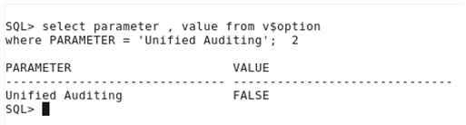

Check the existence of the predefined ORA_SECURECONFIG audit policy.

**col POLICY_NAME format A20  
col AUDIT_OPTION format A40  
set PAGES 100  
select POLICY_NAME, AUDIT_OPTION   
from   AUDIT_UNIFIED_POLICIES   
where  policy_name =  'ORA_SECURECONFIG'  order by 2 ;**

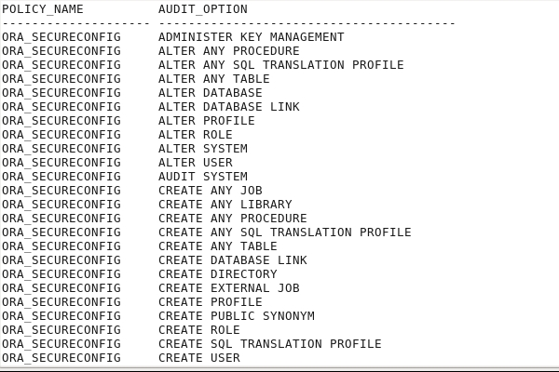

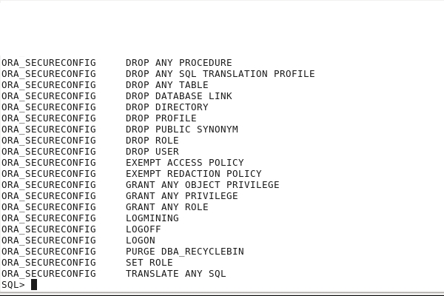

Verify that the predefined ORA_SECURECONFIG audit policy is enabled by default.

**select POLICY_NAME   
from   AUDIT_UNIFIED_ENABLED_POLICIES   
where  policy_name = 'ORA_SECURECONFIG';**

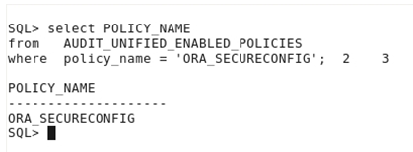

Verify all AUDIT parameters at instance level.

**show parameter AUDIT**

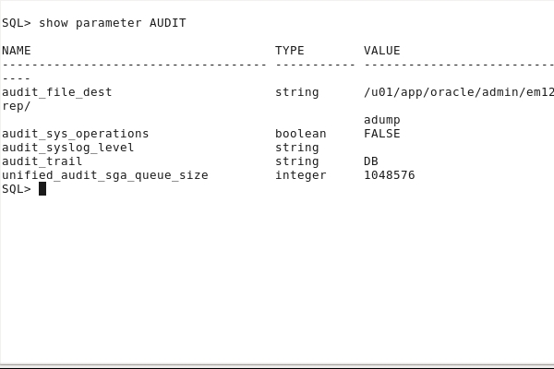

Is user connection still audited?  Verify that audit data is recorded as it is in an 11g Oracle Database although the CREATE SESSION privilege is only audited for LBACSYS, DVSYS and DVF users.

**connect hr/oracle_4U  
connect hr/oracle_4U**

**connect / as sysdba**

**col dbusername format A20  
col action_name format A20  
select action_name, dbusername from unified_audit_trail   
where dbusername='HR';**

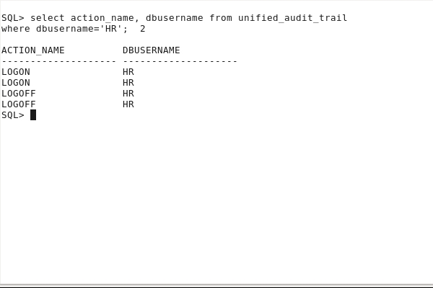

## Enabling the Unified Auditing Mode

In this topic, you enable the unified auditing mode.

Stop all Oracle processes: databases, listener and Enterprise Manager.

**shutdown immediate  
exit**  
  
**ps -ef | grep pmon**  
  
**. oraenv**

**[enter cdb1 at the prompt]**

**sqlplus / as sysdba  
shutdown immediate  
exit**

**lsnrctl stop**

**cd /u01/app/oracle/product/middleware/oms  
export OMS_HOME=/u01/app/oracle/product/middleware/oms  
$OMS_HOME/bin/emctl stop oms**

**. oraenv**

**[enter emrep at the prompt]**

**sqlplus / as sysdba  
shutdown immediate  
exit**

Relink Oracle with the uniaud_on option.

**cd $ORACLE_HOME/rdbms/lib  
make -f ins_rdbms.mk uniaud_on ioracle**

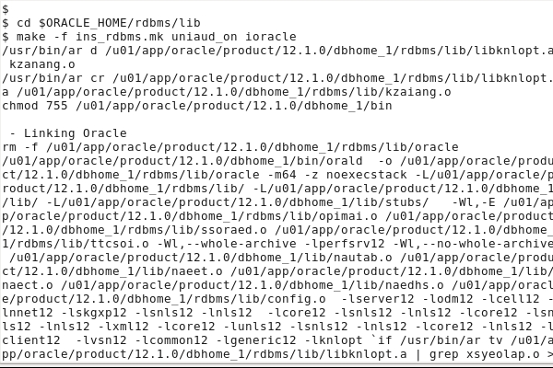

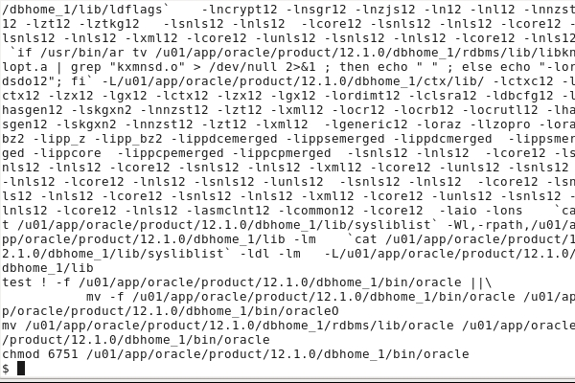

Restart all Oracle processes: Enterprise Manager, listener, databases.For the purpose of the demonstration, only the orcl database instance needs to be started and the listener.

**. oraenv**

**[enter orcl at the prompt]**

**sqlplus / as sysdba  
startup  
exit**

**lsnrctl start**

Verify that unified auditing is now enabled.

**sqlplus / as sysdba**

**select * from v$option where PARAMETER = 'Unified Auditing';**

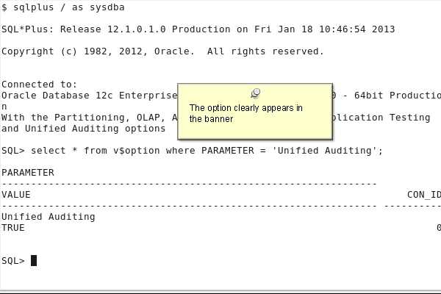

## Auditing RMAN and Oracle Data Pump Operations

In this topic, you audit Oracle Data Pump and Recovery Manager operations.

### Oracle Data Pump Auditing

Create a DP_POL for the Oracle Data Pump component , and more specifically for export operations.

**create audit policy DP_POL actions component=datapump export;**

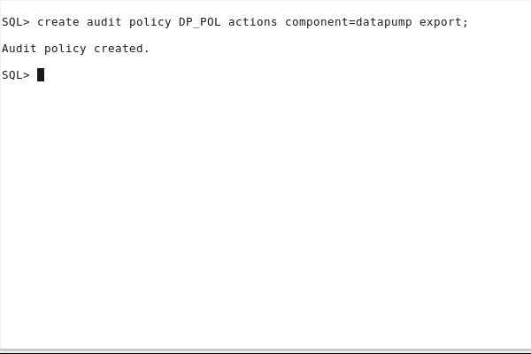

Enable the audit policy.

**audit policy DP_POL;**

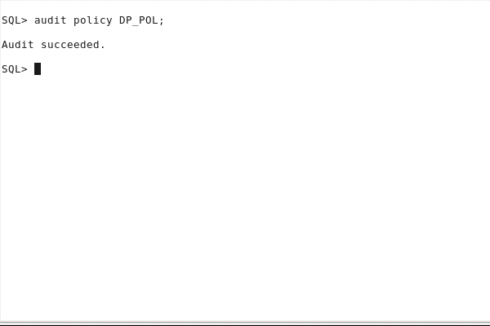

Verify that the audit policy is enabled.col user_name format A10  
col policy_name format A10  
select * from AUDIT_UNIFIED_ENABLED_POLICIES   
where POLICY_NAME like '%DP%';

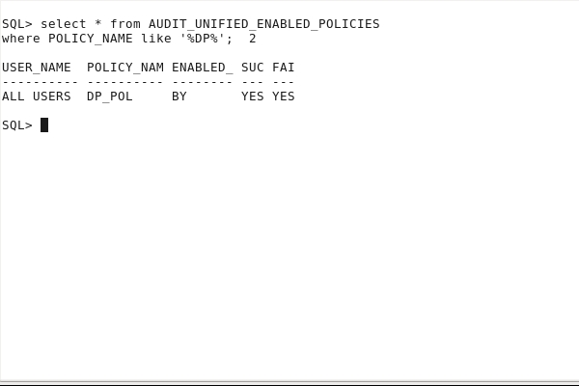

exit

Perform an export operation.

**rm /u01/app/oracle/admin/orcl/dpdump/HR_tables.dmp   
expdp system/oracle_4U dumpfile=HR_tables tables=HR.EMPLOYEES**

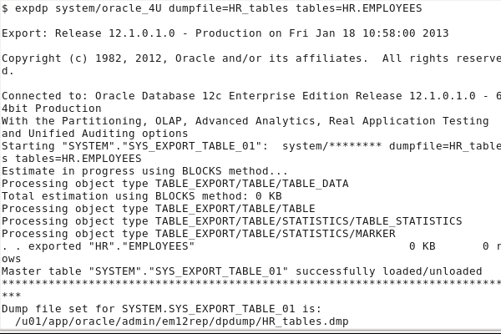

View the resulting audit data.

**sqlplus system/oracle_4U  
   
set pages 100  
select DBUSERNAME, DP_TEXT_PARAMETERS1, DP_BOOLEAN_PARAMETERS1  
from   UNIFIED_AUDIT_TRAIL   
where  DP_TEXT_PARAMETERS1 is not null;**

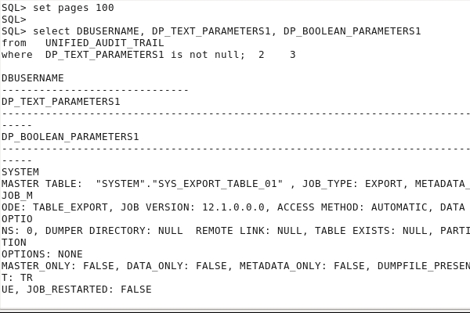

If the audited data is still in memory, you cannot see it. We do not want to wait until the background process flushes the data to disk.

**EXEC SYS.DBMS_AUDIT_MGMT.FLUSH_UNIFIED_AUDIT_TRAIL**

Now you can view the resulting audit data.

**select DBUSERNAME, DP_TEXT_PARAMETERS1, DP_BOOLEAN_PARAMETERS1  
from   UNIFIED_AUDIT_TRAIL   
where  DP_TEXT_PARAMETERS1 is not null;**

**exit**

### RMAN Auditing

You want to audit Recovery Manager backup, restore and recover operations.You do not have to create any audit policy for RMAN operations. RMAN is audited by default.  
Backup any of the tablespaces of the database.

**rman target /  
backup tablespace USERS;**

**exit;**

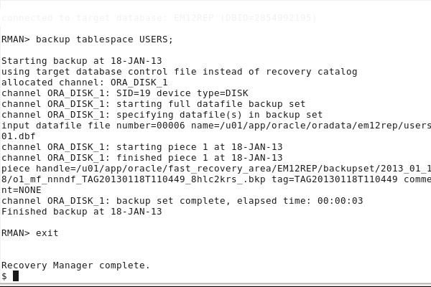

Remove the USERS tablespace datafile.

**sqlplus / as sysdba  
select file_name from dba_data_files where tablespace_name='USERS';  
!rm /u01/app/oracle/oradata/em12rep/users01.dbf**  
  
**alter tablespace users offline immediate;**  
exit

Restore and recover the USERS tablespace datafile.

**rman target /  
restore tablespace USERS;**

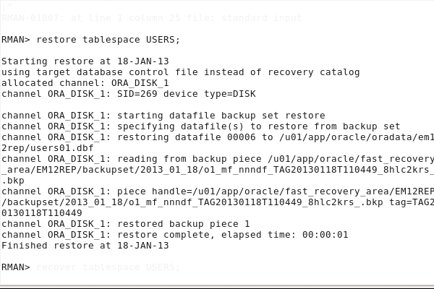

**recover tablespace USERS;**

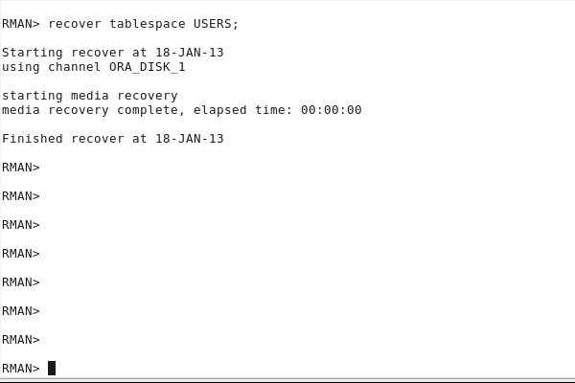

**exit;**View the resulting audit data.  
  
**sqlplus / as sysdba  
alter tablespace users online;**select  DBUSERNAME, RMAN_OPERATION   
from    UNIFIED_AUDIT_TRAIL   
where   RMAN_OPERATION is not null;

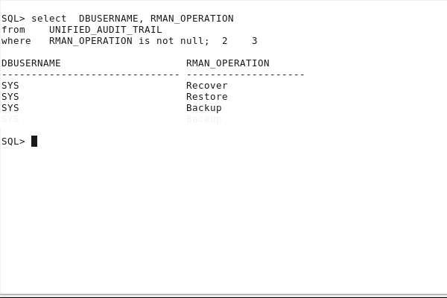

If the audited data is still in memory, you cannot see it. We do not want to wait until the background process flushes the data to disk.

**exec SYS.DBMS_AUDIT_MGMT.FLUSH_UNIFIED_AUDIT_TRAIL**

Now you can view the resulting audit data.

**select DBUSERNAME, RMAN_OPERATION   
from UNIFIED_AUDIT_TRAIL   
where RMAN_OPERATION is not null;**

## Creating Audit Policies to Audit Privileges, Actions and Roles

In this topic, you create audit policies to audit operations that use object and system privileges, roles and perform specific actions.

### Creating a Privilege Audit Policy

Create an audit policy that will audit the user OE using the SELECT ANY TABLE or CREATE LIBRARY system privileges and this for each statement executed. Grant the SELECT ANY TABLE to the user OE.

**create audit policy aud_syspriv_pol   
  PRIVILEGES select any table, create library  
  WHEN 'SYS_CONTEXT(''USERENV'',''SESSION_USER'')=''OE'''  
  EVALUATE PER STATEMENT;**

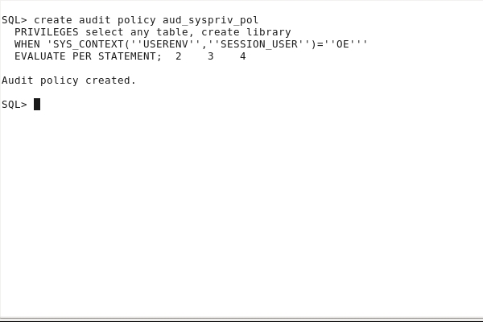

**grant SELECT ANY TABLE to oe;**

Enable the audit policy.

**audit policy aud_syspriv_pol;**

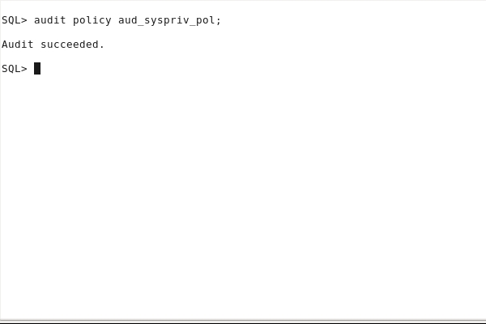

View the audit policy options.

col audit_option format A20  
col policy_name format A18  
select POLICY_NAME, AUDIT_OPTION, CONDITION_EVAL_OPT  
from   AUDIT_UNIFIED_POLICIES  
where  POLICY_NAME ='AUD_SYSPRIV_POL';

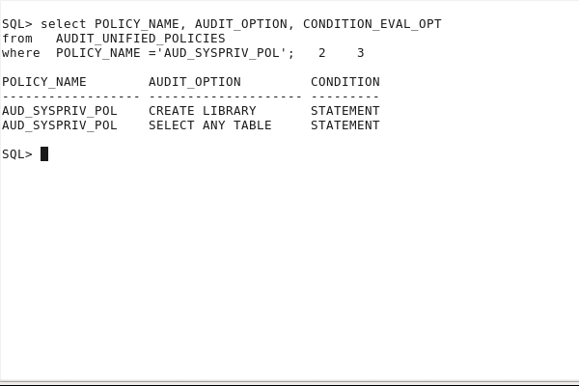

Verify that the audit policy is enabled.

col user_name format A10  
col policy_name format A18  
select POLICY_NAME, ENABLED_OPT, USER_NAME, SUCCESS, FAILURE  
from AUDIT_UNIFIED_ENABLED_POLICIES  
where POLICY_NAME ='AUD_SYSPRIV_POL';

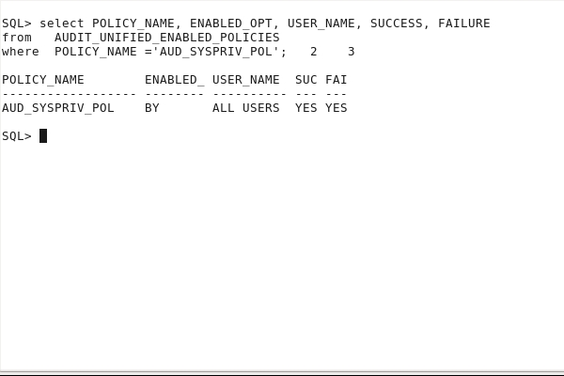

Perform an audited operation.

**connect hr/oracle_4U   
select * from sh.sales;**

**connect oe/oracle_4U  
select * from hr.employees;  
select * from hr.employees;**

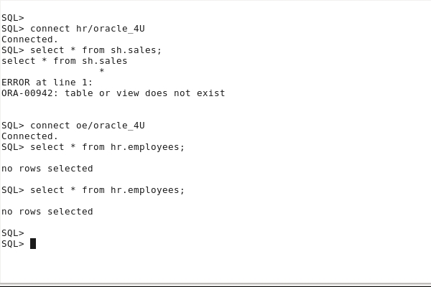

View the resulting audit data.

**connect system/oracle_4U  
  
col action_name format A16  
col policy_name format A18  
col system_privilege_used format A20  
select DBUSERNAME, ACTION_NAME, SYSTEM_PRIVILEGE_USED   
from unified_audit_trail  
where DBUSERNAME in ('HR','OE');**

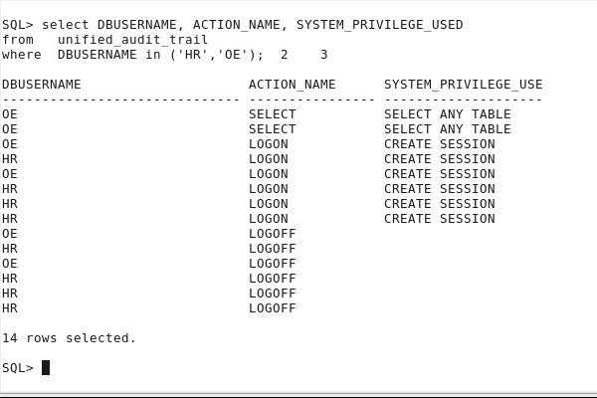

You notice that there are not any records related to HR statements due to the condition defined in the audit policy definition, except those due to the existence of the predefined ORA_SECURECONFIG audit policy  (explained in the first section).

If the audited data is still in memory, you cannot see it. We do not want to wait until the background process flushes the data to disk.

**exec SYS.DBMS_AUDIT_MGMT.FLUSH_UNIFIED_AUDIT_TRAIL**

Now you can view the resulting audit data.

**select DBUSERNAME, ACTION_NAME, SYSTEM_PRIVILEGE_USED   
from   unified_audit_trail  
where  DBUSERNAME in ('HR','OE');**

### Creating an Action Audit Policy

Create an audit policy that will audit any user performing any select or update operation on any object using an object or system privilege, or deleting rows from the HR.EMPLOYEES table.

**create audit policy aud_action_pol   
 ACTIONS select, update, delete on hr.employees;**

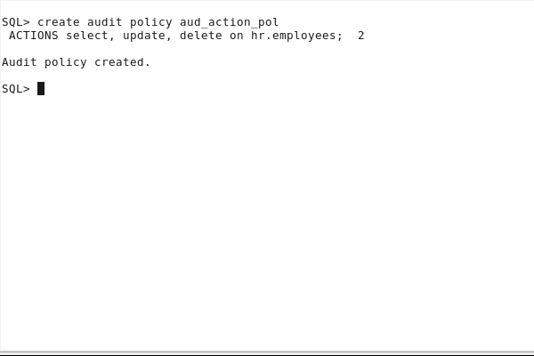

Enable the audit policy for all users except OE.

**audit policy**aud_action_pol EXCEPT oe**;**

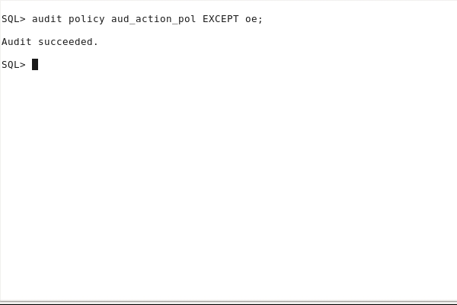

View the audit policy options.

col audit_option format A20  
col policy_name format A18  
col object_name format A18  
select POLICY_NAME, AUDIT_OPTION, OBJECT_NAME  
from AUDIT_UNIFIED_POLICIES  
where POLICY_NAME ='AUD_ACTION_POL';

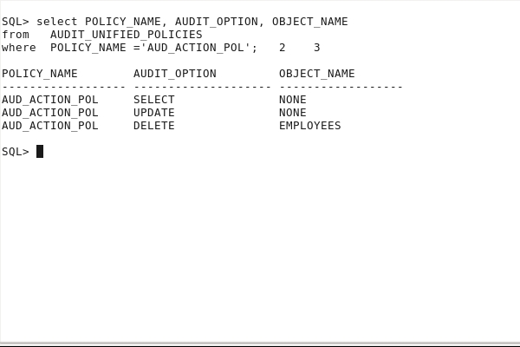

Verify that the audit policy is enabled.

col user_name format A10  
col policy_name format A18  
select POLICY_NAME, ENABLED_OPT, USER_NAME, SUCCESS, FAILURE  
from AUDIT_UNIFIED_ENABLED_POLICIES  
where POLICY_NAME ='AUD_ACTION_POL';

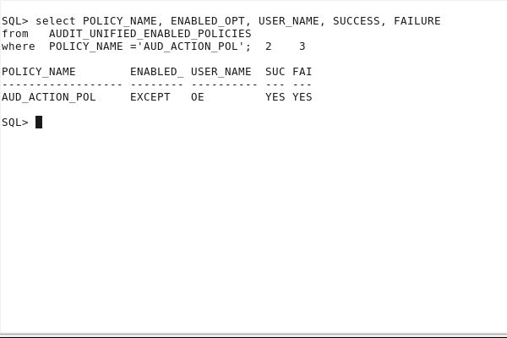

Perform an audited operation. First create a new user DEV and grant appropriate privileges to DEV to execute operations.

**create user DEV identified by oracle_4U;  
grant create session to DEV;  
connect hr/oracle_4U  
grant delete on hr.employees to DEV;**

**connect dev/oracle_4U   
delete hr.employees;**

**connect oe/oracle_4U  
select count(*) from hr.employees;**

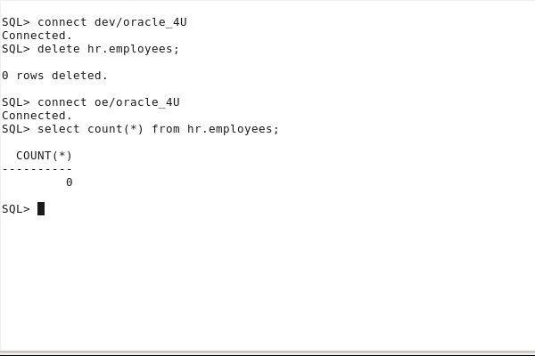

View the resulting audit data.  
  
connect system/oracle_4U  
  
set pages 100  
col dbusername format A8  
col action_name format A8  
col "DATE" format A20  
col  system_privilege_used format A18  
col unified_audit_policies format a22  
select UNIFIED_AUDIT_POLICIES, DBUSERNAME, ACTION_NAME,  
       SYSTEM_PRIVILEGE_USED,   
       to_char(EVENT_TIMESTAMP,'DD-MON-YY HH:MI') "DATE"  
from unified_audit_trail  
where  DBUSERNAME in ('DEV','OE')  
and    ACTION_NAME not in ('LOGON', 'LOGOFF')  
order by 4;

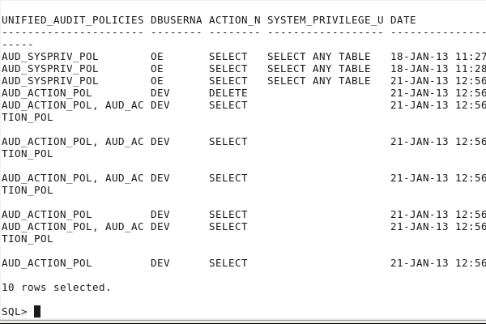

If the audited data is still in memory, you cannot see it. We do not want to wait until the background process flushes the data to disk.

**exec SYS.DBMS_AUDIT_MGMT.FLUSH_UNIFIED_AUDIT_TRAIL**

Now you can view the resulting audit data.

**select UNIFIED_AUDIT_POLICIES, DBUSERNAME, ACTION_NAME,  
       SYSTEM_PRIVILEGE_USED,   
       to_char(EVENT_TIMESTAMP,'DD-MON-YY HH:MI') "DATE"  
from unified_audit_trail  
where  DBUSERNAME in ('DEV','OE')  
and    ACTION_NAME not in ('LOGON', 'LOGOFF')  
order by 4;**

### Creating a Role Audit Policy

Create an audit policy that will audit all users while using the MGR_ROLE role.

**create user JIM identified by oracle_4U;  
  
create role MGR_ROLE;  
grant create tablespace to MGR_ROLE;  
grant MGR_ROLE, create session to JIM;**

**create audit policy aud_role_pol   
  ROLES mgr_role;**

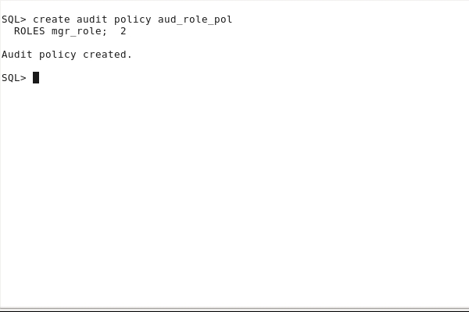

Create an audit policy that will audit all users as soon as these users use the DBA role. Create a DBA_JUNIOR user granted the DBA role.

**create user DBA_JUNIOR identified by oracle_4U;  
grant DBA to DBA_JUNIOR;**

**create audit policy aud_dba_pol   
  ROLES dba;**

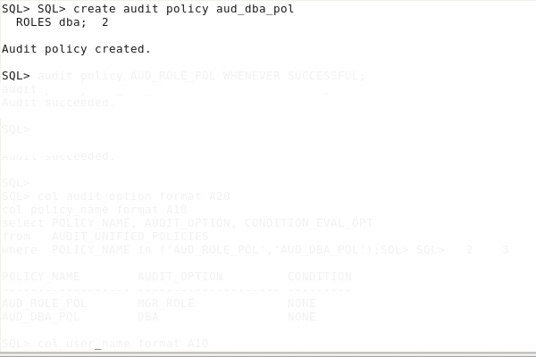

Enable the audit policies whenever the execution completed successfully only.

**audit policy AUD_ROLE_POL WHENEVER SUCCESSFUL;**  
**audit policy AUD_DBA_POL  WHENEVER SUCCESSFUL;**

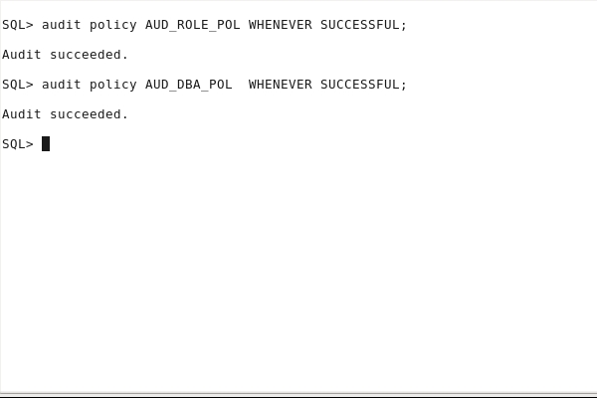

View the audit policy options.

**col audit_option format A20  
col policy_name format A18  
select POLICY_NAME, AUDIT_OPTION, CONDITION_EVAL_OPT  
from   AUDIT_UNIFIED_POLICIES  
where  POLICY_NAME in ('AUD_ROLE_POL','AUD_DBA_POL');**

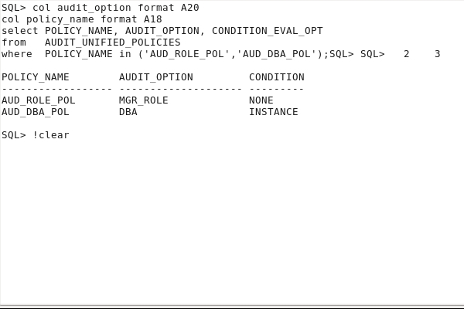

Verify that the audit policy is enabled.

**col user_name format A10  
col policy_name format A18  
select POLICY_NAME, ENABLED_OPT, USER_NAME, SUCCESS, FAILURE  
from   AUDIT_UNIFIED_ENABLED_POLICIES  
where  POLICY_NAME in ('AUD_ROLE_POL','AUD_DBA_POL');**

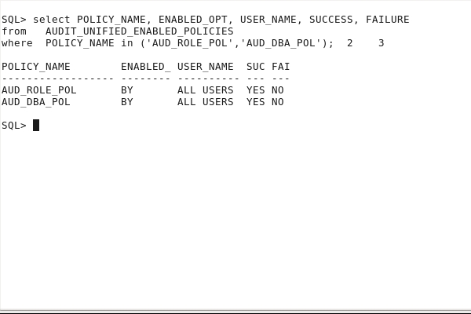

Perform an audited operation for both role type audited policies.

**connect jim/oracle_4U   
create tablespace test datafile '/tmp/test01.dbf' size 10m;  
  
connect dba_junior/oracle_4U  
alter system set job_queue_processes=200;  
alter system set job_queue_processes=100;**

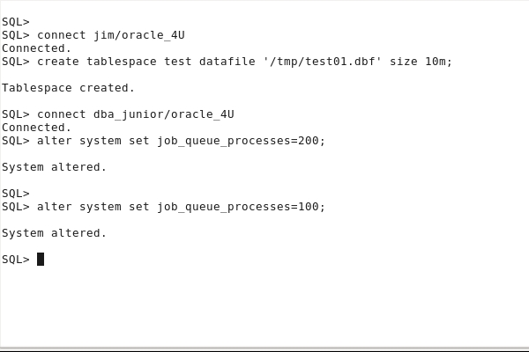

View the resulting audit data.

**connect system/oracle_4U  
   
set pages 100  
col dbusername format A10  
col action_name format A17  
col unified_audit_policies format A30  
col system_privilege_used format A12  
select UNIFIED_AUDIT_POLICIES, DBUSERNAME,   
ACTION_NAME, SYSTEM_PRIVILEGE_USED,   
from unified_audit_trail  
where DBUSERNAME in ('JIM','DBA_JUNIOR')  
and ACTION_NAME not in ('LOGON', 'LOGOFF')  
and UNIFIED_AUDIT_POLICIES like '%AUD_ROLE_POL%'  
or UNIFIED_AUDIT_POLICIES like '%AUD_DBA_POL%');**

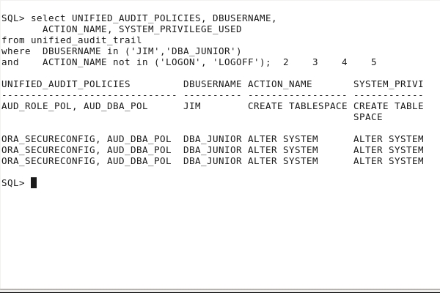

If the audited data is still in memory, flush the data to disk.

**exec SYS.DBMS_AUDIT_MGMT.FLUSH_UNIFIED_AUDIT_TRAIL**

Now you can view the resulting audit data.

**select UNIFIED_AUDIT_POLICIES, DBUSERNAME,   
       ACTION_NAME, SYSTEM_PRIVILEGE_USED    
from unified_audit_trail  
where  DBUSERNAME in ('JIM','DBA_JUNIOR')  
and    ACTION_NAME not in ('LOGON', 'LOGOFF')  
and    (UNIFIED_AUDIT_POLICIES like '%AUD_ROLE_POL%'  
        or UNIFIED_AUDIT_POLICIES like '%AUD_DBA_POL%');**

### Creating a Mixed Audit Policy

Create an audit policy that will audit all users while using the STORAGE_ROLE role or performing any action related to tables.

**create role storage_role;  
grant drop tablespace to storage_role;  
grant storage_role to dev;  
  
grant drop any table to jim;  
  
create audit policy aud_mixed_pol  
  ACTIONS    create table, drop table,   
             truncate table  
  ROLES      storage_role;**

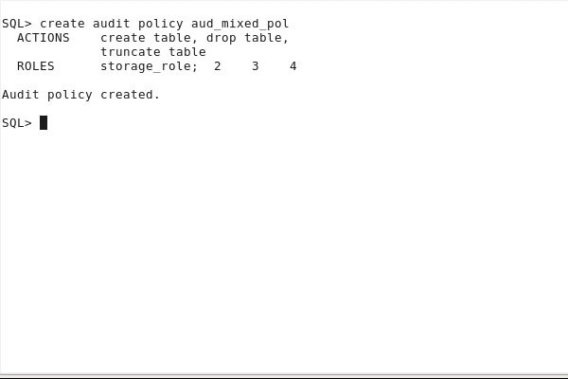

Enable the audit policy.

**audit policy aud_mixed_pol;**

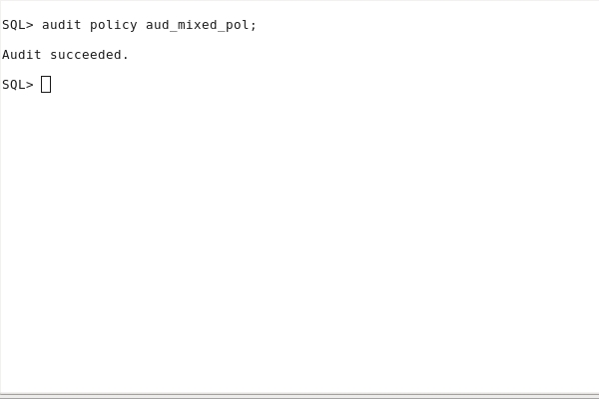

Verify that the audit policy is enabled.

col user_name format A10  
col policy_name format A14  
select * from AUDIT_UNIFIED_ENABLED_POLICIES   
where  POLICY_NAME like '%MIXED%';

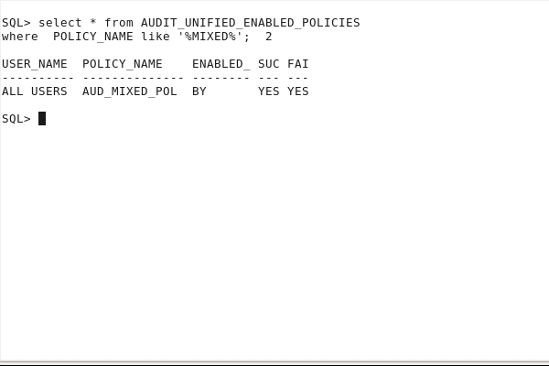

Perform an operation.

**connect dev/oracle_4U   
drop tablespace test including contents and datafiles;**

**connect jim/oracle_4U   
drop table hr.t1 purge;**

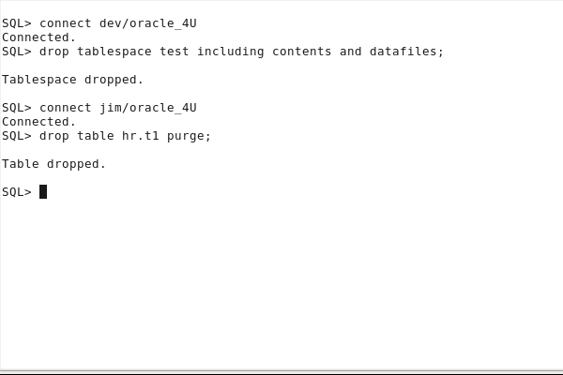

View the resulting audit data.

**connect system/oracle_4U  
   
col action_name format A16  
col policy_name format A18  
col role format A10  
col system_privilege_used format A20  
select UNIFIED_AUDIT_POLICIES, DBUSERNAME,   
       ACTION_NAME, SYSTEM_PRIVILEGE_USED    
from unified_audit_trail  
where  DBUSERNAME in ('JIM','DEV')  
and    UNIFIED_AUDIT_POLICIES like '%AUD_MIXED_POL%'  
and    ACTION_NAME not in ('LOGON', 'LOGOFF');**

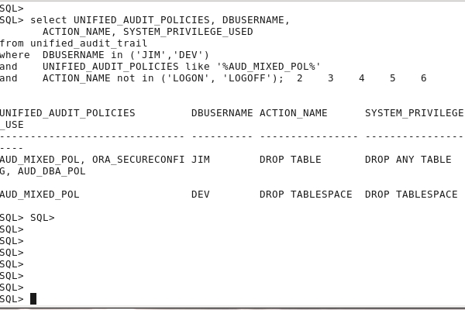

If the audited data is still in memory, flush the data to disk.

**exec SYS.DBMS_AUDIT_MGMT.FLUSH_UNIFIED_AUDIT_TRAIL**

Now you can view the resulting audit data.

**sqlplus system/oracle_4U**

**col action_name format A16  
col policy_name format A18  
col role format A10  
col system_privilege_used format A20  
select UNIFIED_AUDIT_POLICIES, DBUSERNAME,   
       ACTION_NAME, SYSTEM_PRIVILEGE_USED    
from unified_audit_trail  
where  DBUSERNAME in ('JIM','DEV')  
and    UNIFIED_AUDIT_POLICIES like '%AUD_MIXED_POL%'  
and    ACTION_NAME not in ('LOGON', 'LOGOFF');**

## Disabling and Deleting Audit Policies

In this topic, you disable audit policies without dropping them, and then you drop audit policies.

Display the list of enabled audit policies.

**connect / as sysdba  
col policy_name format A20  
select * from AUDIT_UNIFIED_ENABLED_POLICIES;**

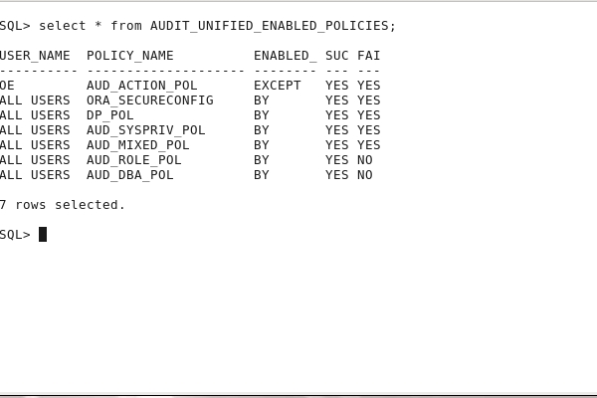

Disable the AUD_MIXED_POL audit policy.

**noaudit policy aud_mixed_pol;**

**select * from AUDIT_UNIFIED_ENABLED_POLICIES;**

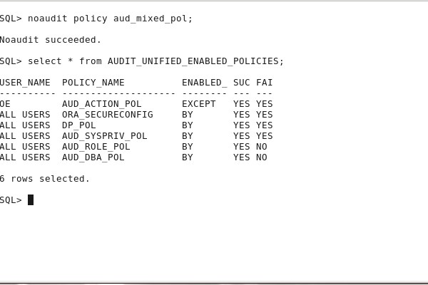

Drop the DP_POL audit policy. You will see that an audit policy can only be dropped after being disabled.

**drop audit policy dp_pol;**

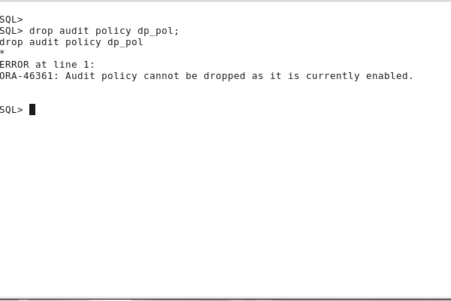

**noaudit policy dp_pol;  
drop audit policy dp_pol;  
select * from AUDIT_UNIFIED_ENABLED_POLICIES;**

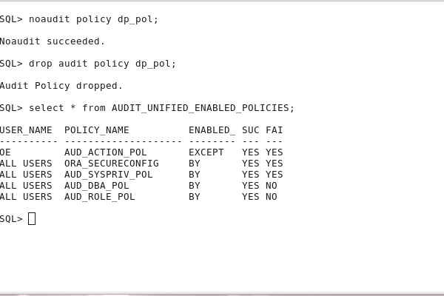 

## Performing Audit Data Cleanup

In this topic, you clean up all audited data from AUDSYS tables stored in SYSAUX tablespace.

You can perform the cleanup manually.

**select count(*) from unified_audit_trail;**

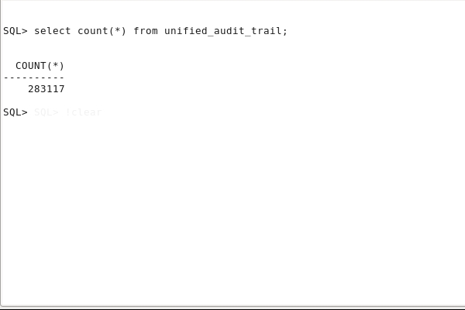

**exec DBMS_AUDIT_MGMT.SET_LAST_ARCHIVE_TIMESTAMP ( -  
     AUDIT_TRAIL_TYPE  => DBMS_AUDIT_MGMT.AUDIT_TRAIL_UNIFIED, -  
     LAST_ARCHIVE_TIME => sysdate)**

**exec DBMS_AUDIT_MGMT.CLEAN_AUDIT_TRAIL( -  
     AUDIT_TRAIL_TYPE        => DBMS_AUDIT_MGMT.AUDIT_TRAIL_UNIFIED, -      
     USE_LAST_ARCH_TIMESTAMP => TRUE)**

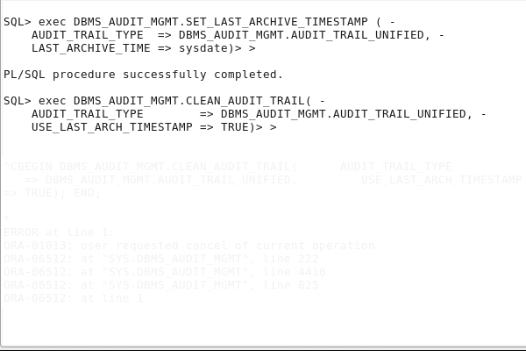

You can also schedule the cleanup.

**exec DBMS_AUDIT_MGMT.SET_LAST_ARCHIVE_TIMESTAMP ( -  
     AUDIT_TRAIL_TYPE = DBMS_AUDIT_MGMT.AUDIT_TRAIL_UNIFIED, -  
     LAST_ARCHIVE_TIME = sysdate)**

**exec DBMS_AUDIT_MGMT.CREATE_PURGE_JOB (-  
     AUDIT_TRAIL_TYPE = DBMS_AUDIT_MGMT.AUDIT_TRAIL_UNIFIED, -  
     AUDIT_TRAIL_PURGE_INTERVAL = 1, -  
     AUDIT_TRAIL_PURGE_NAME = 'Audit_Trail_PJ', -  
     USE_LAST_ARCH_TIMESTAMP = TRUE)**

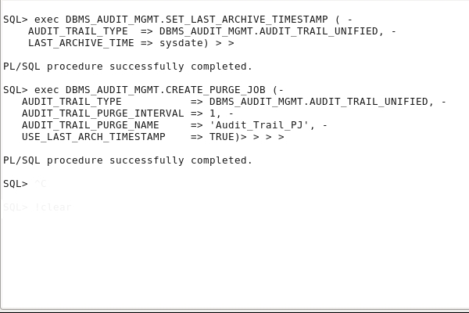

View the cleanup job executions.

**col JOB_NAME format A14  
col STATUS format A12  
col ACTUAL_START_DATE format A40  
  
select JOB_NAME, STATUS, ACTUAL_START_DATE  
from dba_scheduler_job_run_details  
where JOB_NAME='AUDIT_TRAIL_PJ'  
order by ACTUAL_START_DATE;**

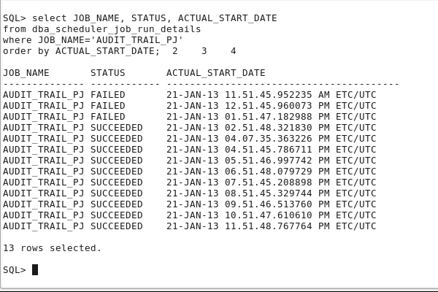

Check if audit data has been purged.

**select count(*) from unified_audit_trail;**

